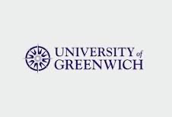

Symposium Organizers
Professor Valerie Thompson (University of Saskatchewan, Canada), Dr. Peter Collins, Professor Ulrike Hahn (Birkbeck College, University of London)

The 14th London Reasoning Workshop: July 24-25, 2023
This year in a different London venue: Greenwich
The event will be hybrid, with both in-person and online presentation and attendance possible

Deadline for Abstract- June 15st, 2023
Send to lrw_2023@outlook.com

